# UFCF85-30-3 Enterprise System Development

# Sprint Review Form

|  |  |
| --- | --- |
| Group: | 18 |
| Sprint: | Week ending 8 February 2022 |
| Members: | Benedict Ramage-Mangles, Ross Williams, Arjun Binning, Michael Duncan, Matthew Hill |

<<Burn-down Chart>>

<<Backlog list>>

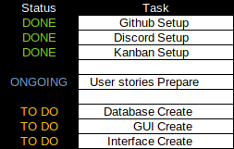

<<Communication Issues>>

We were able to communicate with all group members, however Arjun is unable to attend practical sessions for medical reasons and Matthew is often busy with work. Both are reachable via our Discord server and we have had group meetings through that.

<<Reflections>>

We had issues with monday.com as Kanban board software, and switched to Atlassian/jira instead, but other than that everything seems to be going okay. We do really need to get good at Django, however.

<<Relevant Links>>

github.com/bean64/Group-18-ESD-2022